1. Install node.js  
   <https://nodejs.org/en/download/>
2. Install yarn  
   <https://classic.yarnpkg.com/en/docs/install/#windows-stable>
3. Install vue/CLI (reference: https://cli.vuejs.org/guide/installation.html)
   1. Open command prompt
   2. Enter “yarn global add @vue/cli” (<https://cli.vuejs.org/guide/installation.html>)
4. Install vue (reference: <https://www.npmjs.com/package/create-vue-app>)
   1. Open command prompt
   2. Enter “yarn global add create-vue-app”
5. Install vuetify (reference: <https://www.sitepoint.com/get-started-vuetify/>)
   1. Open command prompt
   2. Enter “npm install vuetify”
6. Retrieve/sync “PatientRegistrationApp” folder from Github
   1. It has everything except for a “node_modules” folder
   2. To get “node_modules” (for the first time), follow these steps:
      1. In the command prompt, navigate to the “PatientRegistrationApp” folder
      2. Type in “vue add vuetify”
      3. When prompted (see below), select “Configure (advanced)” rather than the Default:  
         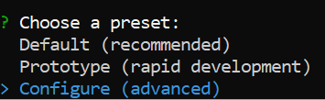
      4. Proceed to select the following options:  
         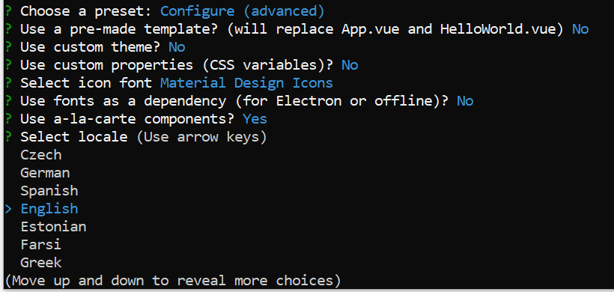
7. To build the application, type “yarn build” into the command prompt (ensure you are in the “PatientRegistrationApp” folder).
8. When complete, enter “yarn serve”
9. When complete, open <http://localhost:8080/> in your browser.